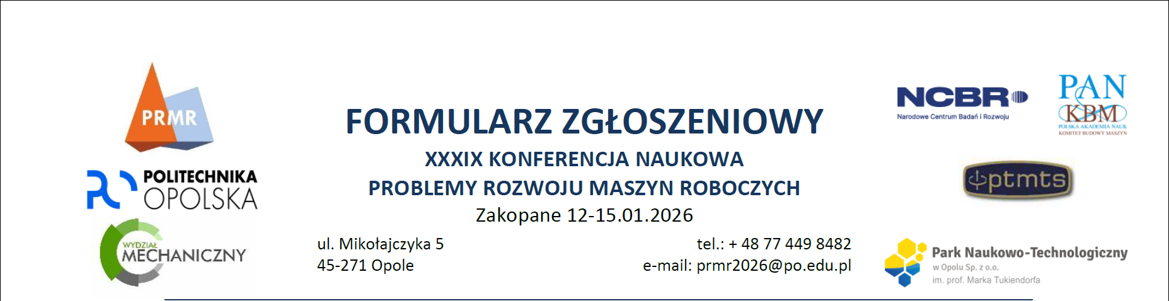

Participant Information

# Academic title / degree, first name and surname:

Kliknij lub naciśnij tutaj, aby wprowadzić tekst.

# Participant’s email address:

Kliknij lub naciśnij tutaj, aby wprowadzić tekst.

# Contact phone number:

Kliknij lub naciśnij tutaj, aby wprowadzić tekst.

**Invoice delivery method:**

Invoice to be sent to the address provided in the billing details or to the following address:

Kliknij lub naciśnij tutaj, aby wprowadzić tekst.

We agree to receive the invoice in electronic form sent to the following email address:

Kliknij lub naciśnij tutaj, aby wprowadzić adres e-mail.

# Type of participation:

Accommodation in a double room (550,00 EUR)

Accommodation in a single room (625,00 EUR)

PhD student in a double room (480,00 EUR)*

Member of the Honorary Committee (500,00 EUR)

Accompanying person (360,00 EUR)

* If selecting this option, please attach a scanned copy of your PhD student ID.

# Diet:

Standard

Other. Please specify: Kliknij lub naciśnij tutaj, aby wprowadzić tekst.

# Additional remarks:

Kliknij lub naciśnij tutaj, aby wprowadzić tekst.



Paper Information

# Paper title:

Kliknij lub naciśnij tutaj, aby wprowadzić tekst.

# Authors (first and last name):

Kliknij lub naciśnij tutaj, aby wprowadzić tekst.

(including the submitter, author order as in the submitted work)

# Author affiliations (name, address):

Kliknij lub naciśnij tutaj, aby wprowadzić tekst.

(if multiple institutions, please label accordingly: 1Institution1, 2Institution2)

# Abstract text (maximum 350 words or 2,500 characters):

Kliknij lub naciśnij tutaj, aby wprowadzić tekst.

# Publication of full paper as a chapter in a monograph:

Yes

No

Required GDPR Consent

I consent to the processing of my personal data for the purposes necessary for participation in the Scientific Conference Problems of Development of Working Machines, in accordance with Regulation (EU) 2016/679 of the European Parliament and of the Council of 27 April 2016 on the protection of natural persons with regard to the processing of personal data and on the free movement of such data, and repealing Directive 95/46/EC (GDPR).

Yes